A Graham Production DJ Service  2834 Parkview Court  Maryville TN 37803  865-405-9024  Make all checks payable to:  Maria Graham | 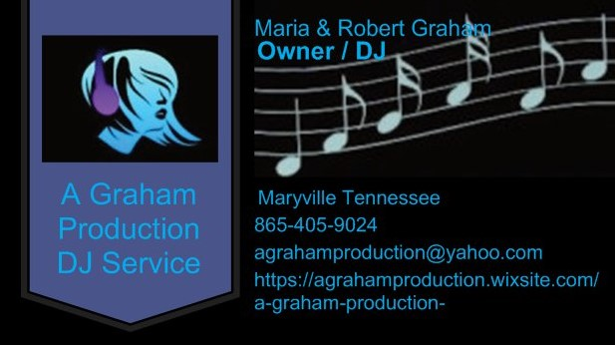
  - Agreement to Perform DJ Services to : Clients Name:__________________ Address: ______________________Phone_____________________

Statement of Work
Date | Services Performed By: | Services Performed For:
[Date] | A Graham Production DJ Service  2834 Parkview Court  Maryville TN 37803  865-405-9024  Make all checks payable to:  Maria Graham | Clients Name:  Clients Address:  Clients Phone __________________  Clients Email_________________________

This Statement of Work (SOW) is issued pursuant to the Agreement between
Clients Name: __________________Clients Address: ______________________
Clients Phone_____________________
(“Client”)_________________________ and A Graham Production DJ Service (“Contractor”),
effective _____day _____Month Of ______Year (of the “Agreement”).
This SOW is subject to the terms and conditions contained in the Agreement between the parties and is made a part thereof. Any term not otherwise defined herein shall have the meaning specified in the Agreement.
In the event of any conflict or inconsistency between the terms of this SOW and the terms of this Agreement, the terms of this SOW shall govern and prevail.

Period of Performance
Under this SOW A Graham Production DJ Service Is pleased to provide DJ service for :

Brides Name: _____________________________________
Address: _________________________________________Phone_______________________________________

Grooms Name: ____________________________________
Address: _________________________________________Phone_______________________________________

Performance Date :__________________________________

Location of event: __________________________________

Scope of Work
Contractor shall provide the Services and Deliverable(s) as follows:
Performance hours: Starting ________ Ending :________Ceremony Time: _____________

Type of service Provided: (check one)
Ceremony music______ Reception______ Both _______

TERMS OF AGREEMENT:
1. Please note that If we are providing service for both ceremony and reception there may be an extra charge if equipment has to be relocated, or if two set ups are required, this fee ranges between $65 -$200.
A Deposit of half down of is required to secure and bind your event day, any and all money collected to secure your event date is NON-REFUNDABLE. If there is a balance left owed to A Graham Production DJ & Photography Service this balance is to be paid IN FULL ONE WEEK BEFORE your event.
DJ service Fee $_____________
Other fees $_______________
Total Amount $_____________
Deposit $_____________
Balance due $______________ Date Due __________________ (one week prior to the date of your Event)
2. Parties entering into this contract are permanently bound to fulfill all terms of this contract unless one or more of the following conditions apply:
A: Both Parties agree to leave this agreement/contract and its responsibilities.
B: The event is completely cancelled and a minimum of 60 days is given in writing.
3. In the event AGP&DJ Service is unable to provided services due to complication beyond Their control a Reputable replacement shall be provided at no more than the original price agreed upon.
4. All information and details must be communicated before 5 days preceding the performance.
5. AGP&DJ SERVICE shall not be held liable for any action arising from or in connection with any individuals not directly affiliated with AGP&DJ SERVICE. Furthermore, the parties contracting AGP&DJ SERVICE agrees to assume full responsibility for any and all damages caused by themselves or their guest involving any of AGP&DJ SERVICE property and equipment.
6. The parties purchasing the services of AGP&DJ SERVICE agrees to allow AGP&DJ SERVICE to use pictures and or video images taken at this event for all promotional purposes.
7. Please inform wedding party and or guest that no "MIC DROPS" will be allowed.
If Someone does succeed in doing so you hereby agree to pay for said damaged equipment in the amount or $600.00.
By signing this contract/SOW you are stating that you understand the terms and conditions described herein and will abide to them.

Clients Signature: ____________________ Date __________

_____________________________________ ____________
Representative of AGP&DJ SERVICE Signature Date

